September 30th, 2013
Common Professional Development
San Juan BOCES

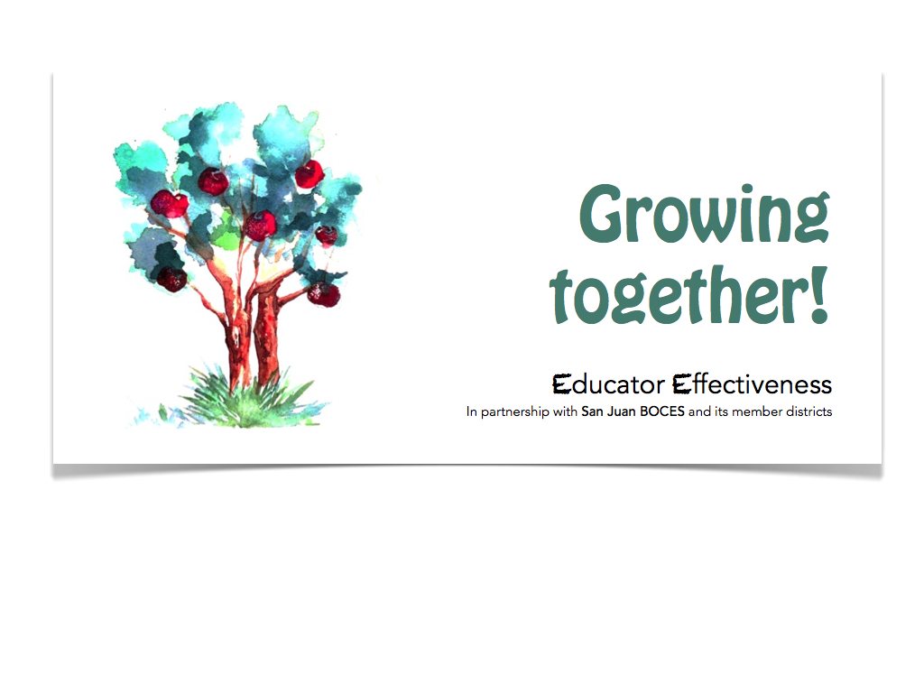

Hello and welcome to the September 30th common professional development day for the San Juan BOCES distrcits. We are excited about the opportunity to offer our area teachers so many great opportunities for development and growth. Thank you in advance for being part of this work.

Overall Details:
Unless otherwise noted all PD sessions will occur from 9:00am-3:00pm in their respective location. Lunch will be provided at all locations and mileage forms will be onsite for participants to complete and turn in.
- Please note: the required materials for each session and be sure to come on time and prepared.
If you have any questions please contact Steve Otter (sotter@sjboces.org)

Literacy Design Collaborative (LDC)

- LDC Part I of Cohort #4 (For our beginning LDC participants, with no LDC interaction so far)
  - Location: Bayfield School Distrcit (Bayfield HS Library)
  - Facilitator: Kimba Rael/Tara Henderson/Heather Hemphill
  - Materials: Laptop computer and your course outline

- LDC Part II of Cohort #3 Elementary
  - Location: Ignacio Middle School (details to be provided on site)
  - Facilitator(s): Gayle Jones-Westerberg/Melissa Carver
  - Materials: Laptop computer, course outline, & any module work

- LDC Part II of Cohort #3 Secondary
  - Location: Ignacio Middle School (details to be provided on site)
  - Facilitator(s): Terry Dunn/Laurie Brandt
  - Materials: Laptop computer, course outline & any module work

- LDC Cross-District work Science (For secondary science teachers that have completed LDC training and are wokring with Module Creator)
  - Location: Mancos School Distrcit (Room J-102 @ Mancos Middle School
  - Facilitator(s): Josh Walton/Miriam Baines
  - Materials: Laptop computer,course outline, any module work

- LDC Cross-District work Social Studies (For secondary social studies teachers that have completed LDC training and are working with Module Creator)
  - Location: Cortez High School- Room 118
  - Facilitator(s): Clay Tallmadge/Emile Benke
  - Materials: Laptop computer, course outline, any module work

- LDC Cross-District work English/Language Arts (For secondary ELA teachers that have completed LDC training and are working with Module Creator)
  - Location: Cortez High School- Room 210
  - Facilitator(s): Nicholas Sandner/Scott Story
  - Materials: Laptop computer, course outline ,any Module Work

- LDC Part III of Cohort #3.5 (This is the Pagosa Middle School cohort that will be finishing their LDC training. This is available to other districts that have participants that would benefit from module scoring and a refresher.)
  - Location: Pagosa Springs Middle School library
  - Facilitator: Mary Rubadeau/Cat Fox
  - Materials: Laptop computer, Student work from Module Instruction

Math Design Collaborative (MDC)

- MDC Introduction (For our beginning MDC participants with no MDC interaction so far)
  - Location: Mancos School District (Room W107 west wing of Mancos High School)
  - Facilitator: Chirstina
  - Materials: Laptop computer and your course outline

- MDC Progression of Concepts: Digging into the Common Core. This will be your district math leadership that is MDC trained (we can have teams of 3 from participating districts)
  - Location: Bayfield High School RM# 213
  - Facilitator: Lisa Bush of Math Solutions
  - Materials: Laptop computer and your course outline

- MDC Cross-District FAL’s work. This will be Math faculty that have been trained either intitially or comprehensively in MDC work and will not be attending the leadership training in Bayfield
  - Location: Mancos School Distrcit (Room W107 west wing of Mancos High School)
  - Facilitator(s): Tiffany Utoft
  - Materials: Laptop computer,course outline any FAL work

Additional Regional Trainings

World Languages Teachers
  - Location: Cortez High School (room 206)
  - Facilitator(s): Sonja Copeland
  - Materials: Laptop computer and course outlines
*Course description: September 30th we will go over what all of us will be using to show growth as far as assessments and lesson plans for this school year. Many of us will be measuring the same grade and therefore will be sharing assessments, lesson plans, and ideas. In addition we will review CDE materials provided for Common Core shift.

Art Teachers
  - Location: Middle School Art room (Mancos) for the morning and then the Mancos Public Library for the afternoon
  - Facilitator(s): Mara Vinton
  - Materials: Laptop computer and course outlines
*Course description: Our plan for September 30th is to go over what all of us will be using to show growth as far as assessments and lesson plans for this school year. Many of us will be measuring the same grade and therefore will be sharing assessments, lesson plans, and ideas.

Technology Director Meeting-Common Technology and Support
  - Location: San Juan BOCES Durango (SW Colorado eSchool Office)
  - Facilitator(s): Tod Lokey
  - Time: 9:00-noon
  - Materials: Laptop computer
*course description: A half-day work-session will allow regional technology directors to share their work with teacher and student systems and to talk about shared needs with eSchool students. Examining common tools - such as implementing Google Apps - will be a major focus of the time together. We will also look at teacher websites and working towards making learning management tools, such as those used by the eSchool, available and supported in more schools

Technology Directors, Teachers and Facilitators Meeting-Supporting Innovative Technologies in the Classroom
  - Location: San Juan BOCES Durango (SW Colorado eSchool Office)
  - Facilitator(s): Tod Lokey
  - Time: 1:00pm-4:00pm
  - Materials: Laptop computer
*Course description: The afternoon focus of technology in our districts will expand to include district leadership that directly supports teachers in the how-to of using technology to improve instruction and student learning. We will include the technology aspects of the new teacher evaluation rubric as a general need, but will critically look at what expectations for student technology use are in place and where we can go together in the future.

School Counselors-Safe2Tell Strategy
  - Location: Durango, La Plata Electric offices
  - Facilitator(s): Kathy Morris/Suzi Karrer

*Course description:
Core Components of the Safe2Tell Strategy
The focus of Safe2Tell is to ensure that every Colorado student, parent, teacher and community member has access to a safe and anonymous way to report any concerns about their safety or the safety of others. Safe2Tell accomplishes this by early intervention and prevention through awareness, education and accountable follow-up.
Train the Trainer Certifications and Staff Trainings: In order to spread the message of the Safe2Tell program among Colorado schools, Safe2Tell developed a training program that certifies individuals and leaders to present Safe2Tell information, materials, and classroom discussion materials to their own communities.
Conversation Jumpstarts: Safe2Tell provides training modules to provide counselors and school resource officers that offer a tangible tool lead them in guided classroom discussions. Available Conversation Jumpstart topics include bullying, cyber bullying, dating, sexting, weapons, dating, depression, and substance abuse. While discussing issues trainers talk about the code of silence, when it is appropriate to make a report, and what happens when a report is made.
Intervening at the school level at the earliest opportunity by caring, committed adults: The Safe2Tell program provides students with the opportunity to seek help, guidance and counseling from a trusted source before a situation grows out of control. Safe2Tell offers education and training to adults on identifying at-risk behaviors in students and creating safe learning environments.
.

